CREATE AND CONFIG IBM CLOUD SERVICE

**[Create IBM Watson IoT Platform And Device](https://github.com/IBM-EPBL/IBM-Project-5268-1658753471/tree/main/Create%20And%20Configure%20IBM%20Cloud%20Services/Create%20IBM%20Watson%20IoT%20Platform%20And%20Device)**

|  |  |
| --- | --- |
| Date | NOVEMBER 2022 |
| Team ID | PNT2022TMID11798 |
| Project Name | IOT Based Real-time River Water Quality Monitoring and Control System |
| Maximum Marks | 2 Marks |

Step 1—Open the ibm cloud web page

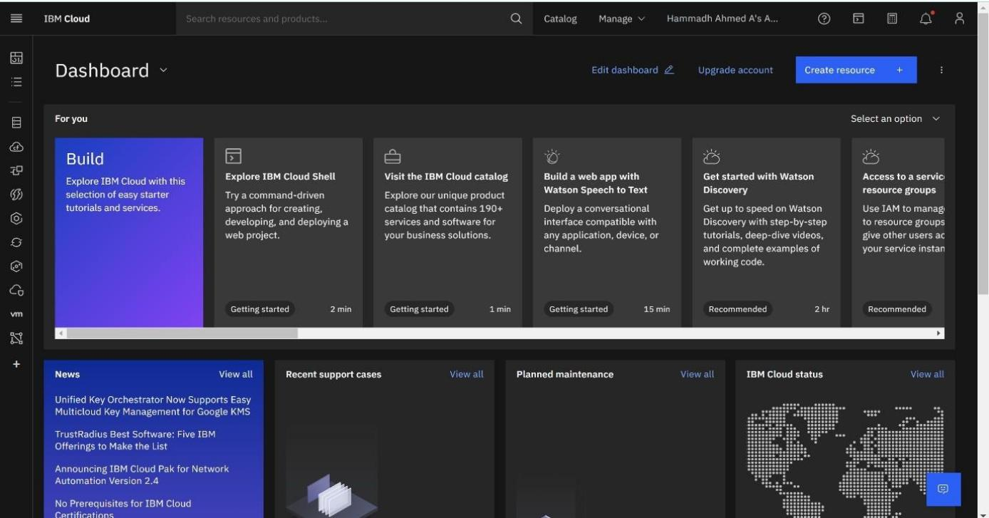

Step 2—Select the catalog session

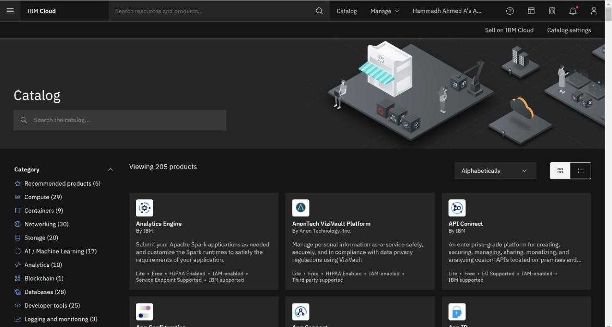

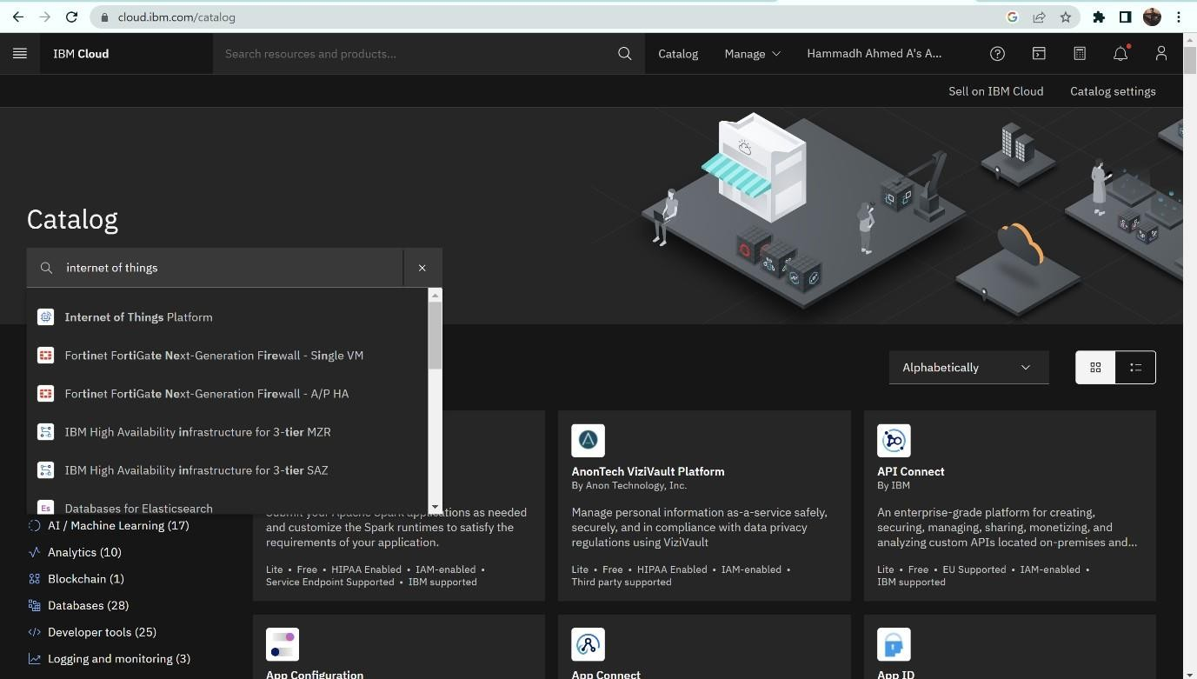

Step 4—Select the Internet Of Things Platform and Accept the terms and condition and selectCREATE to create the IBM WATSON platform

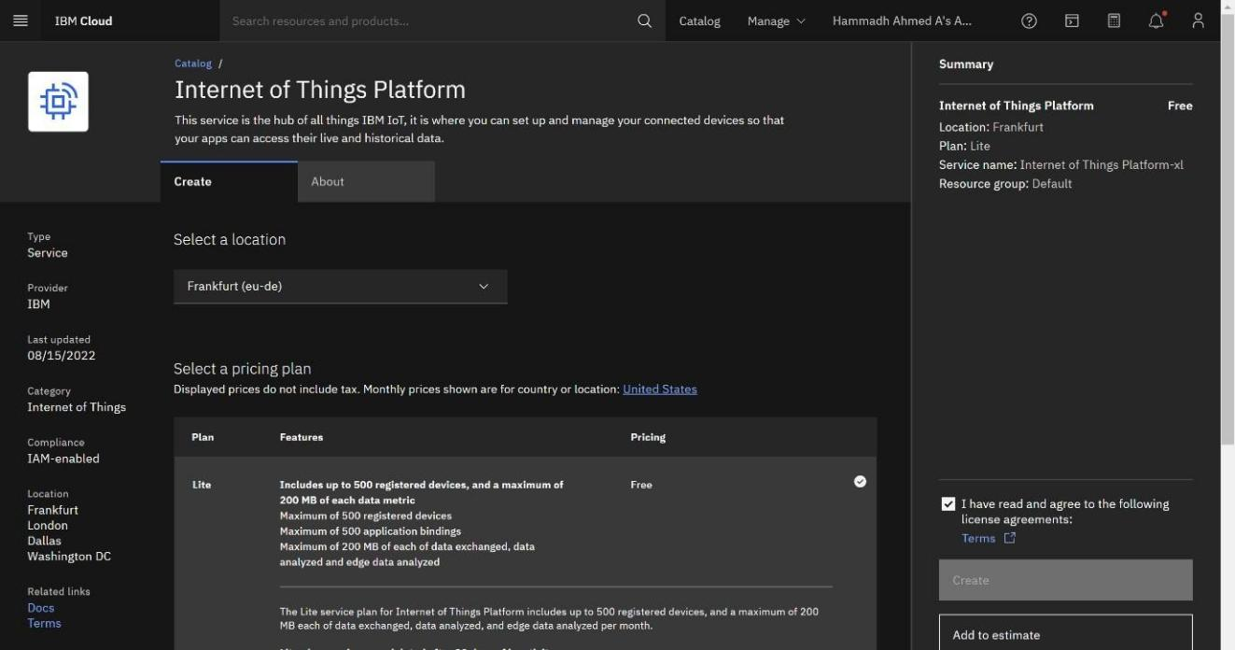

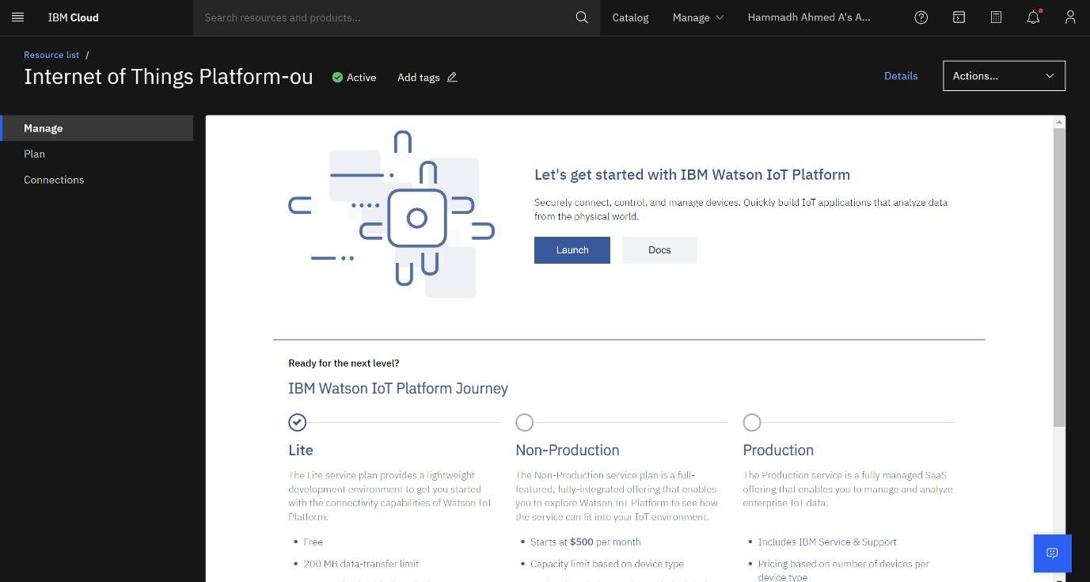

Step 6—Sign in

